MATHS HL EXTENDED ESSAY
How can the knowledge of vectors, game theory, and algorithms contribute to a better planning of the strategies in the game of chess?
Perçem İlke Akova

Word count: 3951

Table of Contents
Abstract 1
Introduction 2
Research Question 2
Why Chess 2
Chess and Vectors 2
Determining captures with the help of vectors 4
Chess and the Game Theory 10
Classification of chess in game theory 10
Methods of Combinatorial Game Theory 10
How do chess engines operate using the game trees 11
Chess and Algorithms 12
Alpha Beta Pruning 19
Conclusion 22
References 23
Appendix 24
Basic Rules of Chess 24

Abstract
Chess is a truly complex game with astronomically large numbers of unique games, and with a large number of intriguing concepts. Therefore it is an interesting game to examine in various ways. In this essay the ways that mathematics improves the understanding of chess are explored. Topics that are explored in the essay are vectors and chess, knight’s tour problem, chess and game theory, algorithms and chess computers. While exploring those topics, various tree diagrams, chess position diagrams and visuals are used. For the reader with minimal knowledge on chess, introductory rules and game basics are included in the appendix section, with some explanation in the body of the essay.
In this essay it is concluded that chess, aside from being an entertaining game, has some interesting options for applying mathematical concepts. Chess can be a great tool for understanding some mathematical concepts such as vectors by understanding the movement of pieces; just as math can be truly helpful for developing better strategies in chess. For the practical purposes, analysis of chess games are purposefully shortened down, as chess games have more than 400 possibilities even at the beginning of the 2nd move.
It is concluded that understanding mathematics can help to come up with better strategies in chess. Better understanding of vectors can help with imagining better move sequences. When used with chess computers, game theory and some algorithms can help to “solve” the game, ultimately reaching to the best game for white and the best game for black. However there were some limitations. The main limitation was the astronomically high numbers of possible unique chess games and the lack of computer technology that can compute all of the different games and board positions, solving them with “brute force”.

Introduction

Research Question
How can the knowledge of vectors, game theory, and algorithms contribute to a better planning of the strategies in the game of chess?

Why Chess
Chess is an enjoyable board game that requires mental vitality, logical analysis, visual memory, strategic thinking, but it is also like an open book displaying many subjects in mathematics. From vectors to geometry, logic to probability or game theory, chess can be a very efficient tool for applying maths. Movement of some pieces such as knight involve some understanding of vectors. Deciding on the best move in chess requires understanding of minimax algorithm and decision trees alongside with visual memory. Being a perfect example of zero-sum two-player game, chess is also a game with perfect information. Having finite possible games, chess is still unsolved due to the astronomically high number of possible positions. Due to all of these, chess is a perfect game for applying some concepts of mathematics.

Chess and Vectors
Each piece in chess has a specific way that they move. A rook can only move right and left, up and down while a bishop can only move diagonally. In fact, “capture” of pieces can be considered as finding interception points of specific vectors given in a specific time, or “turn”.
Assume that horizontal side of the square chess board is the “x” axis, and vertical side is the “y” axis. Starting from point (1,1), a chess board is set up on this rectangular coordinate system.
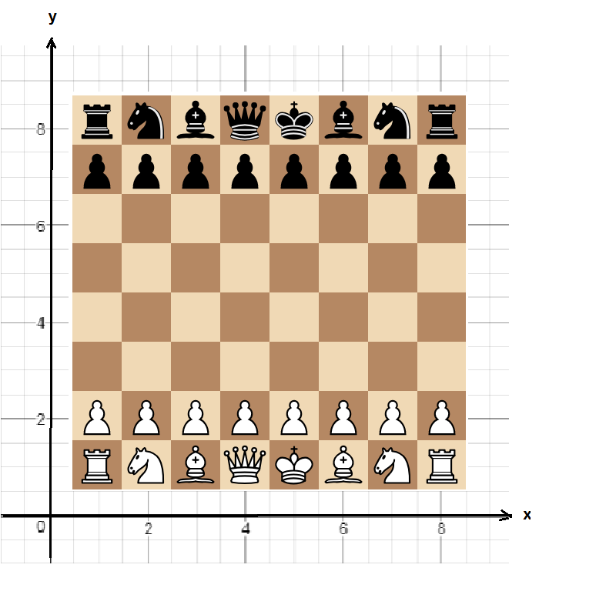
In the setup position, position vectors of each piece can be represented like this:
White pieces from left to right: Black pieces from left to right:
Rook 1: i+j Rook 1: i+8j
Knight 1: 2i+j Knight 1: 2i+8j
Bishop 1: 3i+j Bishop 1: 3i+8j
Queen: 4i+j Queen: 4i+8j
King: 5i+j King: 5i+8j
Bishop 2: 6i+j Bishop 2: 6i+8j
Knight 2: 7i+j Knight 2: 7i+8j
Rook 2: 8i+j Rook 2: 8i+8j

Determining captures with the help of vectors
Consider the following position. 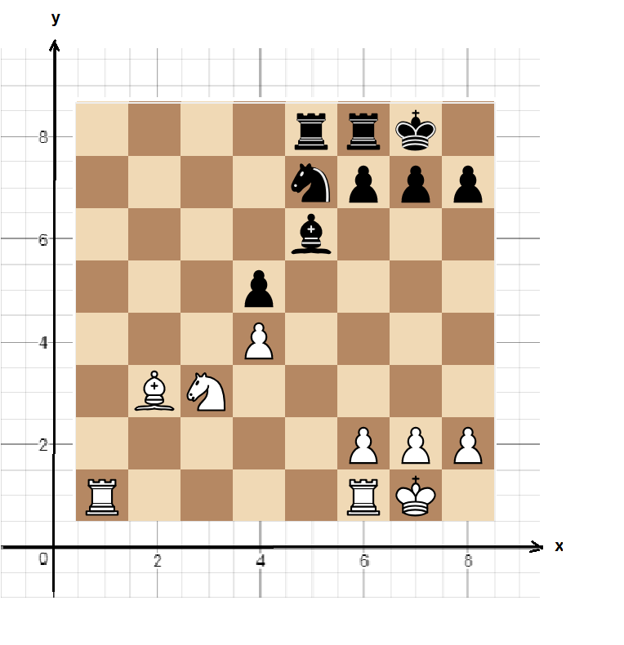
To determine the value of the exchange, the simplest way is to count the number of pieces that are attacking to the square and compare it to the number of pieces that are defending the square (In this case, 2 white pieces are attacking and 2 black pieces are defending D5 pawn, or the pawn with the position vector 4i+5j). By using the vector formulas of the pieces, this position can be transformed into a word problem that is easily solved by vectors:
White Knight’s position at any t:
$$\left({3 \atop 3}\right)+t\left({1 \atop 2}\right)$$
Black Knight’s position at any t:
$$\left({5 \atop 7}\right)+t\left({-1 \atop -2}\right)$$
White Bishop’s position at any t:
$$\left({2 \atop 3}\right)+t\left({2 \atop 2}\right)$$
Black Bishop’s position at any t:
$$\left({5 \atop 6}\right)+t\left({-1 \atop -1}\right)$$

The problem of this way of presenting is caused by the “time” factor. In chess, players are playing with “turns”, not at the same time. So, order of captures is usually important. To convert it into a perfect word problem, “t” can be divided to estimated turns that the specific piece moves. Hence, vectors of the pieces can be altered in this way:
White Knight’s position at any t, n being the number of turns that it will be played in:
$$\left({3 \atop 3}\right)+\frac{t}{n}\left({1 \atop 2}\right)$$
Black Knight’s position at any t:
$$\left({5 \atop 7}\right)+\frac{t}{n}\left({-1 \atop -2}\right)$$
White Bishop’s position at any t:
$$\left({2 \atop 3}\right)+\frac{t}{n}\left({2 \atop 2}\right)$$
Black Bishop’s position at any t:
$$\left({5 \atop 6}\right)+\frac{t}{n}\left({-1 \atop -1}\right)$$
Hence, it can be converted into the following problem:
Four pieces with vector expressions$A = \left({5 \atop 7}\right)+\frac{t}{n}\left({-1 \atop -2}\right)$,$B= \left({3 \atop 3}\right)+\frac{t}{n}\left({1 \atop 2}\right)$,$C=\left({2 \atop 3}\right)+\frac{t}{n}\left({2 \atop 2}\right)$ and$D=\left({5 \atop 6}\right)+\frac{t}{n}\left({-1 \atop -1}\right)$ where n is the order that the pieces move, are attacking to the point P with the position vector$\left({4 \atop 5}\right)$. If the last piece to reach point P is winning, and it is white’s turn, find which player is winning. ($n ∈N$ and A represents black knight, B represents white knight, C represents white bishop and D represents black bishop)
As it is white’s turn, first piece to move will be a white piece. Since both bishop and knight have the same “value”, it is not important if the white chooses to capture with the knight or with the bishop first. Assume the white captures with the knight first. Then$B= \left({3 \atop 3}\right)+t\left({1 \atop 2}\right)$. As black also has a bishop and a knight protecting the square on the point P, whether the black player moves the knight or the bishop first is unimportant. Assume the black too captures with the knight first, leading to$A = \left({5 \atop 7}\right)+\frac{t}{2}\left({-1 \atop -2}\right)$. Then white captures with the bishop,$C=\left({2 \atop 3}\right)+\frac{t}{3}\left({2 \atop 2}\right)$. Finally black captures with the bishop,$D=\left({5 \atop 6}\right)+\frac{t}{4}\left({-1 \atop -1}\right)$. It is clearly seen that for any value of t, black pieces reach to the designated square last. Hence, black player will be profiting from this piece exchange.
Consider the following problem: How many moves in minimum does the knight require to reach the desired square in the following position?
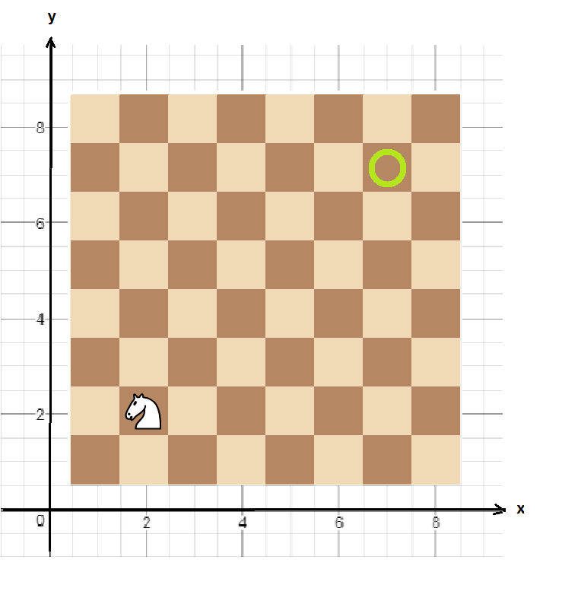
The knight can move in the shape of “L”, therefore its movement can be represented with the following vectors:
$\left({1 \atop 2}\right)$, $\left({2 \atop 1}\right)$, $\left({-1 \atop 2}\right)$, $\left({-1 \atop -2}\right)$, $\left({-2 \atop -1}\right)$, $\left({1 \atop -2}\right)$, $\left({2 \atop -1}\right)$, $\left({-2 \atop 1}\right)$
The square is located in$\left({7 \atop 7}\right)$, so the knight should move in the positive direction to reach the point. Vectors that are in the positive vertical and positive horizontal direction are $t\left({1 \atop 2}\right)$and$t\left({2 \atop 1}\right)$. So, the player can choose to play any of these 2 moves. Assume player chooses to move the knight with the vector$t\left({1 \atop 2}\right)$. Notice, when$t=3$, the knight is on the point$\left({5 \atop 8}\right)$. To reach the desired point, the knight has to move one unit down and two units to the right, which can be represented by another vector of the knight’s movement;$\left({2 \atop -1}\right)$. Hence, it can be deduced that it would take four moves for the knight to reach to the desired point.
Consider the same position. What would be the square that would take the highest number of moves to reach by the knight? Notice the sequence of the knight’s moves. Every time it moves, it visits a point matching with a square that has the opposite colour of the square matching with the point the knight’s initial position. Hence, for the knight that has an initial position on a point matching with a black square, it would take an odd, “2n-1” number of moves to reach a white square. For other black squares, it would take an even, “2n” number of moves. Hence, the knight in the given position would require 5 moves to reach (7,8) or (8,7).
The interesting movement of knight introduced one of the most famous problems, Knight’s Tour problem. It follows as: How can a knight travel across the whole 8x8 board, visiting each square only once, given that it can begin from any square to move?
Solutions are divided into two categories, closed tours and open tours. Closed tours require the knight to end at a square that is accessible from the square that it started. There are various estimations about the number of closed tour solutions, one estimate being 33,439,123,484,294 (Löbbing & Wegener, 1996) but more commonly accepted number of directed solutions is 26,534,728,821,064 (including rotations and reflections as solutions). Directed solutions count the same path travelled in the opposite direction as separate solutions. Hence undirected closed tours have the half of the solutions.
However, not all rectangular boards have solutions for the closed knight’s tour. It is proven by using graph theory, and Hamiltonian cycle principles that for a board with dimensions$m ×n$, where$m≤n$, if$m=1, 2 or 4$, or $n=3, 4 or 6$when$n=3$, or $m and n$ are odd, there are no solutions for the closed knight’s tour problem. (Schwenk, 1991)
To solve the knight’s tour problem, several methods were developed. Although it can be solved thanks to human intuition, new unique solutions are discovered by mainly computers following either brute force or neural networks, or the problem is approached by using Warnsdorff's rule, which is a heuristic for finding solutions.
Warnsdorff’s rule states that knight should move to the square with least number of accessible other squares. For example, the knight in the following position has three options to move.
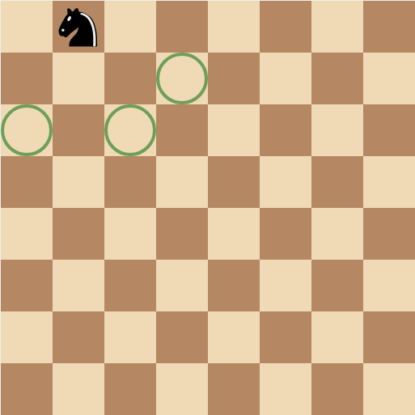
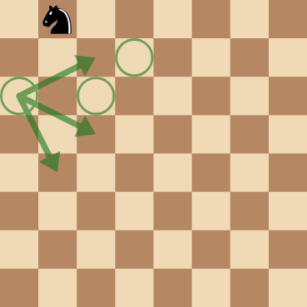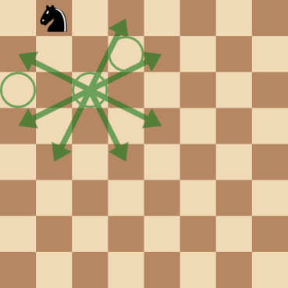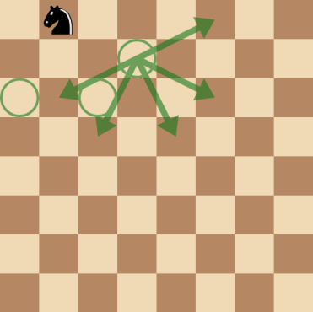
The square on the left gives 3 options for knight, the middle one gives 7 options, and the one on the left gives 5 options. Hence the knight has to move to the square on the left. However, Warnsdorff’s rule is only a practical method to have an approach for the problem, and is not guaranteed to work. A program written with python that solves knight’s tour problem by using Warnsdorff’s rule can be reached from the following link: (https://github.com/douglassquirrel/warnsdorff)

Chess and the Game Theory

Classification of chess in game theory
Chess is a two player turn based (sequential) game, with no chance moves (such as rolling dice). Both players do not hold information which is secret. Position is clear to both players, and both of the players can see the moves of the other player. Hence, chess can be classified as two-person zero-sum game with perfect information. Due to this classification, chess falls under combinatorial game theory’s field of work.

Methods of Combinatorial Game Theory
Games studied in combinatorial game theory are also divided into two sub-categories: partisan games and impartial games. In impartial games both players have same set of moves, whereas in partisan games players are limited to only one set of possible moves. For example, games similar to “draw the last stick” are impartial games, as both players will choose from the common set of sticks. However in games like checkers, each player can move only one set of pieces. As white player can only move the white pieces and black player can only move the black pieces, chess is regarded as a partisan game.

How do chess engines operate using the game trees
Chess engines calculate the position on board using their specific formulae and repeat the process for the next moves to determine optimum strategy for a player with the minimax algorithm. Hence, positions are given numerical values. Closer to zero suggests given that players choose the moves that the engine has chosen, the game ends with a draw. If the numerical value of the position is greater than zero, white wins; if the numerical value of the position is negative, black wins. The same position with inverted pieces and turns has the value with the opposite sign as such:
Black to move
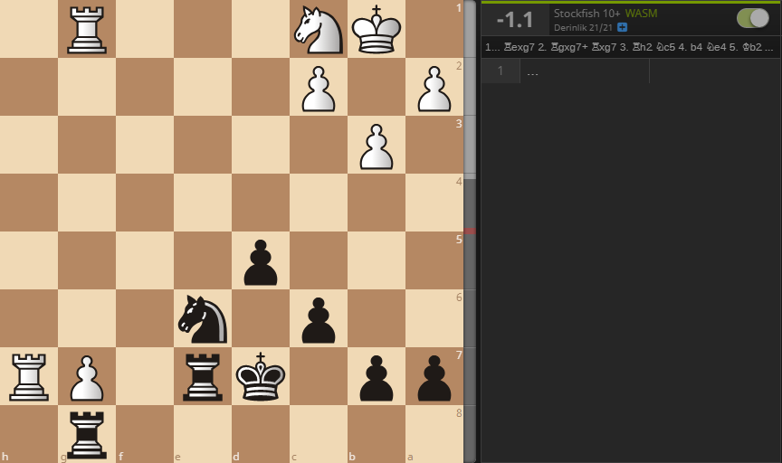
White to move
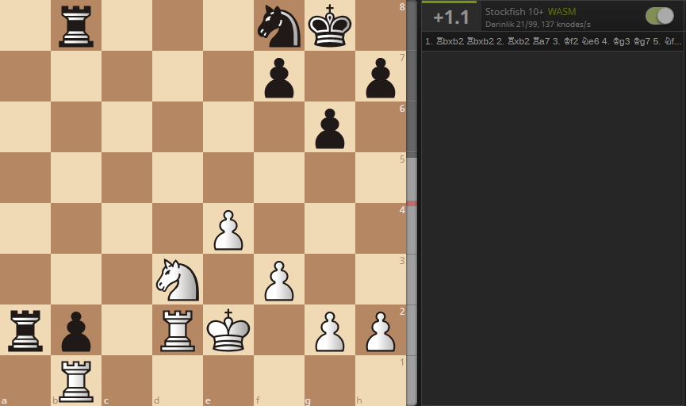

Chess and Algorithms
Especially in the creating process of chess engines, various algorithms are used. One of the most famous algorithms is the “minimax algorithm”, which also has many uses in game theory.
Chess engines have their specific formulae for “calculating” a value for the position on board, initially to decide which player has the better pieces, king safety, piece mobility, etc. The value of the board is usually expressed with positive and negative real numbers; positive if white is winning, negative if black is winning. For example, consider the following position.
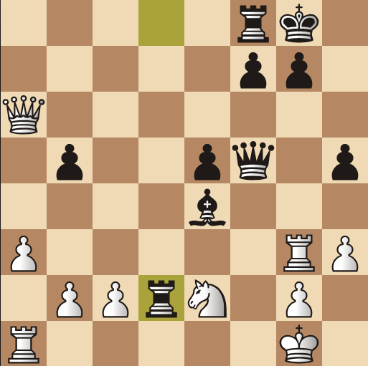
Assume that the chess engine is very basic and can only consider number of pieces on board to determine which player has the better position. A very simple formula for determining the value of the position would be subtracting number of black pieces from the number of white pieces. Then, the simplest formula for the position would be
$$P=N_{W}-N_{B}$$
where P is the value of the position, $N_{W}$ is the number of white pieces and $N_{B}$ is the number of black pieces. In this case, value of the position is
$$P=10-10=0$$
However, in chess, each piece has their own value; a queen is more valuable than a pawn. Ignoring the position, chess pieces have the following values:

Queen: 9
Rook: 5
Bishop: 3
Knight: 3
Pawn: 1

King has uncalculatably high value as winning the king would mean winning the game. Considering this, a better position calculating formula would be
$$P=\left(N_{WP}+{3N}_{WB}+3N_{WK}+ 5N_{WR}+9N_{WQ}\right)-\left(N_{BP}+{3N}_{BB}+3N_{BK}+ 5N_{BR}+9N_{BQ}\right)$$
where $N_{WP}$ is the number of white pawns, $N_{WB}$ is the number of white bishops, $N_{WK}$ is the number of white knights, $N_{WR}$ is the number of white rooks and $N_{WQ}$ is the number of white queen(s) and the rest is the same only with black.
Hence, the position would have the value of
$$P=\left(5+3×0+3 ×1+ 5 ×2+9×1\right)-\left(5+3×1+3×0+5×2+9×1\right)=37-37=0$$
which would be still a draw.
On the other hand, pieces in chess do have dynamic values; their positions can alter their values. In some cases, pawns can be more valuable than major pieces like the queen. Usually, pieces that are closer to the centre or pieces that have highest mobility are more valuable assets. However, number or the values of the pieces are not only factors to be considered. (See appendix for more detailed information)
As seen in this example white is clearly winning in this position, as Qh6 would threaten both mate, and the black rook on d2. Then black can only react to one of the threats, preferably mate, and then the rook will fall. The reason for that is a chess player must consider many factors such as king safety, possible threats, tactical positions like “pin”s, pawn structure, imbalances on the board and more. Then, the player must consider the same factors for the next moves. This makes particularly chess a difficult game to represent mathematically. Still, chess engines which use mathematical calculations to decide on the best move are considered to be better players compared to humans. (Stockfish 10+ calculates the position as +7.4, seeing 21 moves ahead.)
After calculating the value of the position, and next possible positions, a chess engine needs to “decide” on the move it will play next. In turn based games like chess, one of the ways of determining the best move is to use decision trees and minimax algorithm, given every position has their own specific values.
Consider the following mate:
- e4 – f6
- d4 – g5
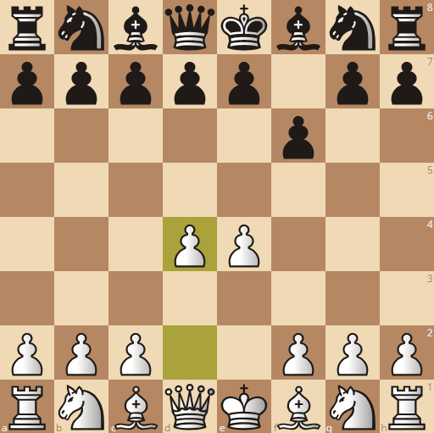
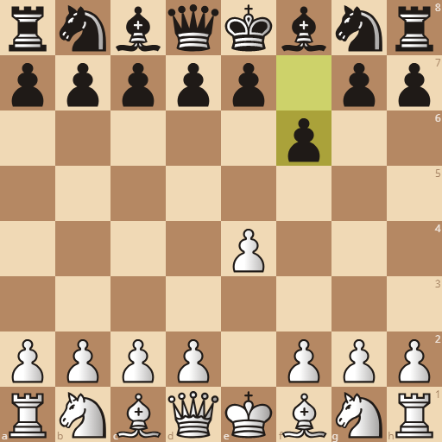
- Qh5#
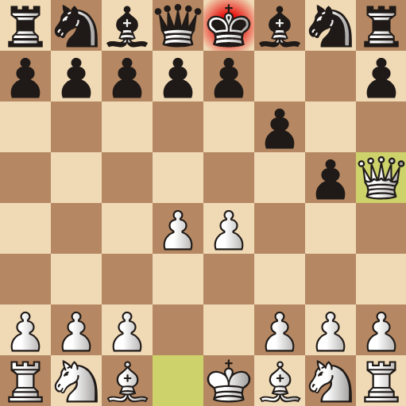
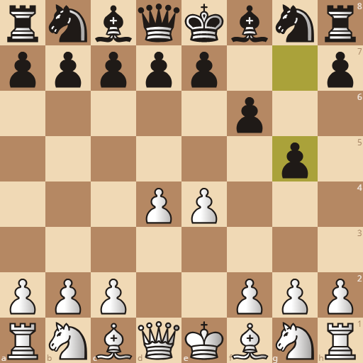
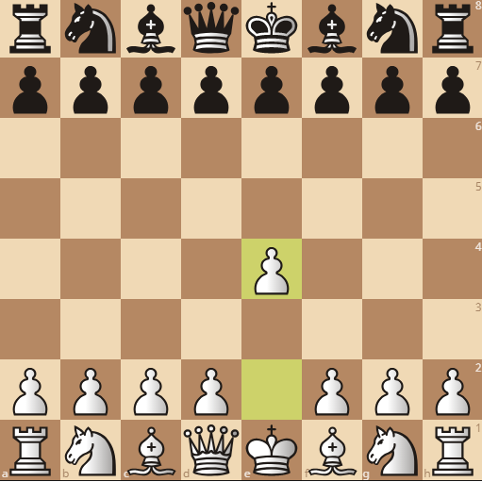

Black player blunders at move three. True alternative for that move would be Nf6, Nh6, f6, d5. Each move is followed by many more possible moves. Even if only 2 moves are calculated as the next move, after 3rd move there are n being the number of moves,$2^{2n}$possible outcomes. Hence, for the sake of simplicity assume only two options are available; one good move and one bad move.

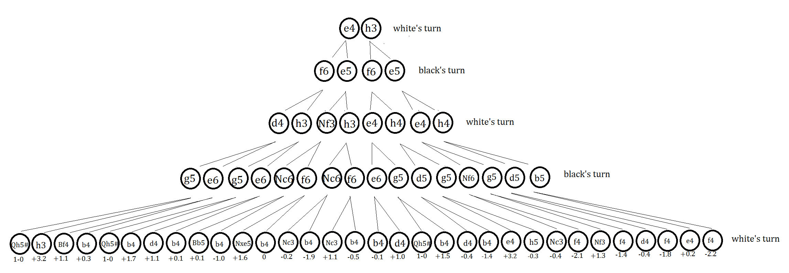
Assume that both are very good players and can see 3 moves ahead. Both players know that the other player will choose the better option when available, and both players will try to minimise the outcome for the other player. As it is white’s turn, white knows, whichever move white chooses, black will choose the move that will lead to most negative outcome at the beginning of move 2 (as more negative value means better position for black). Also, after white moves at move 2, black will choose the most negative outcome for the position in move 3. Hence, players get a game tree such as this:

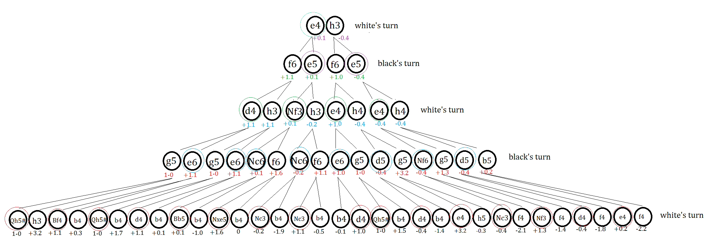

In this tree, black player knows that white will choose the position that has the highest value possible when given the choice. Take Qh5# move and h3 move at the left end of the tree as an example. If black chooses to play g5, assuming white has two choices; white player will choose the move that would end with a checkmate, Qh5#. Similarly, if black player chooses to play e6, white player will choose to play Bf4 as it has higher value than b4. Since black player knows this, if black has two options, g5 and e6, black must choose e6 to minimise white’s advantage. Given both players play perfectly with only given moves are available, the most likely path would look like
- e4 – e5
- Nf3 – Nc6
- Bb5 - ...
As seen in the example, black player chooses the option that would minimise the value of the position while the white player chooses the option that would maximise the value of the position, hence the “minimax” algorithm. Of course, in a real game, after the 1st move there would be 400 different games to play unlike this game tree. Chess has astronomically high number of possible games, even thought to be more than the estimated number of atoms in the entire observable universe. Claude Shannon calculated the number of possible positions on the board as$\frac{64!}{32!8!²2!⁶}$. (Though this calculation includes illegal positions such as pawns in the first rank, two kings next to each other, etc.) He also estimated the number of unique possible games as${ 10}^{120}$, which is a truly large number. Usually this number is compared to the estimated number of nanoseconds passed since the beginning of the universe, which is roughly estimated to be in the order of magnitude of${10}^{26}$.
Although according to Zermelo’s theorem chess has theoretically better strategies, since chess has so many unique games, creating a full game tree (hence solving chess) is concluded to be practically impossible with today’s technology. According to Claude Shannon, the mathematician who also came up with Shannon’s number, it would take ${10}^{90}$ years to calculate all variations in chess to construct a full, solved game tree. (Shannon, 1950)
As attempting to calculate complex game trees of chess for computers take too much computing power, to reduce the workload and simplify the game tree, a method called as “alpha beta pruning” is used.

Alpha Beta Pruning

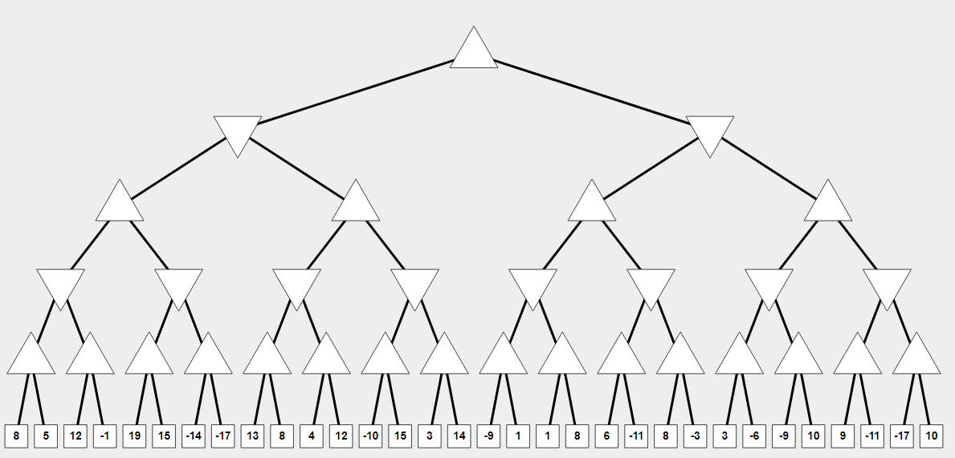
Alpha beta pruning is a method to reduce the number of required evaluations in a complex game tree. Basically, it stops exploring a branch if the value on the leaf is already worse than the previous one. White player being triangles facing upwards and black player facing downwards, assume that the game tree is:
(Kamiko)
Examine the first branches:
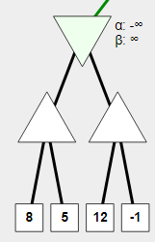
As bottom layer triangles will have the maximum values, and the top triangle will have the minimum, the evaluation takes place as this:
- Since$8>5$; white player will choose the move leading to 8, hence first triangle is 8.
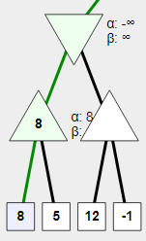
- Since the 3rd leaf is 12, and$12>8$; it is a worse move for the black player. When the black player has the option to choose from, black player will choose the move leading to 8 (the first triangle) when possible. Hence, there is no need further exploring the branch on the right.
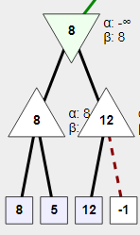
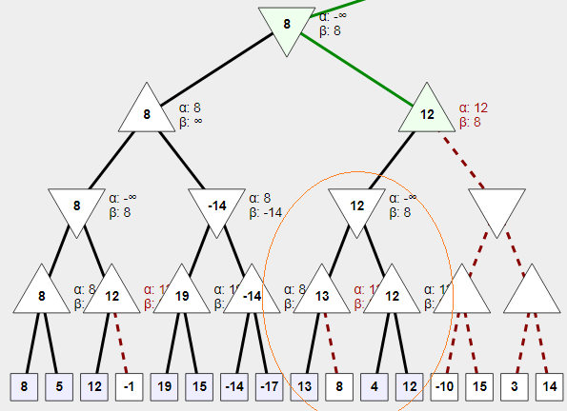
Consider this:

Since the evaluation for the circled branch turned out as 12, and for the black player there is already a better move existing, the black player will choose the branch leading to the node with the value 8. Hence, branch on the right side can be “pruned” or cancelled out.
With the help of this method, chess engines are able to process game trees with more complexity and higher depth given the same amount of time.

Conclusion
Considering that the throne of chess mastery was already taken away from humans by machines long ago, chess still remains as one of the most popular board games across the globe. Chess as an entertaining board game has some mathematical concepts embedded into it. Hence, it can be an important tool for exploring those concepts. In this essay some areas of mathematics that are explored through chess while helping to understand chess are vectors, algorithms, and the game theory.
However, there are serious limitations for trying to apply mathematics to chess. As chess has astronomically high numbers of possible different unique games, it is difficult to apply combinatorial game theory to chess, even with the help of chess computers. Applying vectors is also not problem-free, due to the concept of “turns” in chess, and usually it is easier to just count the number of pieces attacking or defending a specific square. Also, coming up with an accurate position evaluation function is a limitation, as nobody, including computers, still knows what type of positions lead to the absolute victory. This is why chess engines that attempt to calculate the values for the positions are slowly replaced by AIs that develop their own ways of understanding chess.
Nevertheless, chess has managed to be an intriguing board game that occupied the minds of famous mathematicians for centuries. Euler himself was occupied with the knight’s tour for some time. Studying chess helped to develop better computer technologies, and soon playing chess became the standard for them. Now understanding and mastering chess stands as the ultimate challenge before the AIs, such as Google’s Alpha-Zero.

References

- Analysis Board. (2010). Retrieved from Lichess.org: https://lichess.org/analysis
- Kamiko, A. (n.d.). Alpha Beta Pruning Practice. Retrieved from http://inst.eecs.berkeley.edu/~cs61b/fa14/ta-materials/apps/ab_tree_practice/
- Löbbing, M., & Wegener, I. (1996). The Number of Knight's Tours Equals 33,439,123,484,294 &mdash; Counting with Binary Decision Diagrams. The Electronic Journal of Combinatorics , 3 (1) .
- Mycielski, J. (1992). Games With Perfect Information. In R. Aumann, & S. Hart, Handbook of Game Theory (Vol. I, pp. 42-68). Elsevier Science Publishers B.V.
- Polak, B. (2007, September 5). Game Theory: Lecture 1 Transcript ECON 159. Open Yale Courses.
- Schwalbe, U., & Walker, P. (1997). Zermelo and the Early History of Game Theory. Retrieved from http://www.math.harvard.edu/~elkies/FS23j.03/zermelo.pdf
- Schwenk, A. J. (1991). Which Rectangular Chessboards Have a Knight's Tour? Mathematics Magazine , 325-332.
- Shannon, C. (1950). Programming a Computer for Playing Chess. Philosophical Magazine .
- Wu, Q., Yu, F., & Landry, M. (n.d.). A COMBINATORIAL GAME THEORETIC ANALYSIS OF CHESS. Retrieved from https://web.stanford.edu/~wqy/research/Math%20191-%20Chess.pdf
- Yanovskaya, E. B. (2014, November 9). Two-person Zero-sum Game. Retrieved from Encyclopedia of Mathematics: https://www.encyclopediaofmath.org/index.php/Two-person_zero-sum_game

Appendix

Basic Rules of Chess

Chess is played on a 8x8 board, there are 32 white squares and 32 black squares.
Each piece moves differently.
Pawns can only move forward. If the pawn is moved for the first time, it can move for two squares. Pawns take other pieces diagonally. En passant however, can take the pawn if the en passant is on the fifth rank for white and fourth rank for black, and the opponent’s pawn moved for two squares, eventually reaching next to the en passant. However, this capture must be done immediately. When a pawn reaches to the first rank of the opponent (1st rank for black and 8th rank for white) the pawn can be promoted to a different piece; knight, bishop, rook, or queen. Pawns cannot jump over pieces.
Bishops can only move diagonally. Hence, a bishop starting on the dark squares can only venture on the black squares. Initially each player starts with two bishops, one on a light square and one on a dark square. Bishops cannot jump over pieces.
Rooks can move upwards, backwards, and to the sides. They cannot jump over pieces.
Knights are unique pieces; they move in L shape, two squares in one direction and one square in another direction with 90 degrees, and can jump over other pieces.
Kings can move for a square in any directions. However, two kings cannot be next to each other. When a piece attacks the king, it is considered as “check”. If the player cannot block the path, cannot take the piece attacking the king or the player’s king under the check cannot escape, it is considered as a “checkmate”, and the game is over. If the king cannot move, and there are no other legal moves, but the king is not under a check, it is considered as a draw. King and the rook can move together in one turn to perform “castle”. While castling, the king moves two squares towards the rook and the rook moves right next to the king. However, for performing castle, the king or the rook must be moving for the first time, there must be no pieces between the rook and the king, and there must be no piece of the opponent that is controlling any of the squares on the king’s path. The king must not be on “check” while performing a castle.
The queen is the strongest piece, it can move up and down and diagonally, like a combination of a rook and a bishop. It cannot jump over the pieces.
There are relative values of the pieces; a pawn is worth only 1 point, a knight is worth 3 points, a bishop is worth also 3 points, a rook is worth 5 points, a queen is worth 9 points, and king is so valuable that it is infinitely valuable as losing the king is the “game over”.
Please note that depending on the position, pieces may be more or less valuable. In a closed position, usually knights are more valuable than bishops. A white pawn that has reached to the 7th rank is very powerful and valuable that in some cases the opponent sacrifices even a rook to stop that pawn.
Chess notation: the writing system to record moves of the pieces. Each move is represented with
- The initial letter of the piece that is moving (except the Knight and the pawns. The knight is represented with the letter N and for pawns no symbol is used)
- The square that the piece is moving to. If the piece captures another piece while moving to the designated square, a “X” is written at the end of the move. If the piece threatens the king with its move, “checking” the king, a “+” is written at the end of the move. If it is the final move resulting with a checkmate, “#” is written at the end.
An example:
- e4 – e5 (white moves its pawn to e4 square. Black moves its pawn to e5 square.)
- Nf3 – Nf6 (white moves its knight to f3 square. Black moves its knight to f6 square.)
- Nxe5 – Nxe4 (white’s knight captures the pawn on e5. Black’s knight captures the pawn on e4.)
- Qe2 – Nf6
- Nc3+ - ... (when the white knight moves, the path between the white queen and the black king is no longer blocked, hence it is a check)

“...any of the options which the player chooses in a setting where the outcome depends not only on their own actions but on the actions of others.” (Polak, 2007)
see Chess and the Game Theory section for definitions
see Chess and the Game Theory section for definitions
Simply, relative values of the pieces are determined as 1 for pawns, 3 for bishops and knights, 5 for rooks, 9 for queens and infinitely large for the kings.
also known as proof by exhaustion, “is a method of mathematical proof in which the statement to be proved is split into a finite number of cases and each case is checked to see if the proposition in question holds.” (Proof by exhaustion, 2012)
“A real or virtual device, modeled after the human brain, in which several interconnected elements process information simultaneously, adapting and learning from past patterns.” (Neural Network)
“Of or relating to a usually speculative formulation serving as a guide in the investigation or solution of a problem.” (Heuristic)
“pay-off functions are numerically equal and opposite in sign.” (Yanovskaya, 2014)
a game which all information is available for all players, in example of chess, board and past moves are completely visible for both players. “At each time only one of the players moves, that the game depends only on their choices, they remember the past, and in principle they know all possible futures of the game” (Mycielski, 1992)
There are one hundred sticks in a bag. Players can draw 1, 2 or 3 sticks per turn. Person drawing the last stick loses the game. This game has a forced win strategy.
Zermelo’s theorem states that if the game of perfect information, the board is finite, there are only two players, there is no chance element and it is a sequential game, forced wins or draws exist.
Although today’s computers are still unable to completely solve chess, advancements in computer sciences, especially quantum computing may reduce the time needed to reach the level of technology that’s close to solving chess.

